FORMAN CHRISTIAN COLLEGE (A CHARTERED UNIVERSITY)


CSCS 306 – Embedded Systems
Fall 22
Lab - 02

Adeel Akmal – 231465420
Muhammad Sameed Gilani - 231488347

You should attach the hard copy of signed and graded lab / assignment handout as second page of this report.
From third page onwards following headings should be included:
- Introduction
  - Should carry information of all major library /user defined functions used in this lab/assignment.
- Your logic / algorithm in simple English. Bullet points are appreciated.
- Your code
- Circuit diagram (drawn using some online tool. Hand drawn diagrams are not accepted)
- Picture of the running hardware.
- Screen shots of at least three outputs of your code with appropriate inputs.
- References if any

INTRODUCTION:
TASK1:
Simply had to turn 4 LEDs from right to left. Then blink all of them thrice, after which the 4 LEDs turned on from left to right. This is repeated in an infinite loop until the power is disconnected.
TASK2:
The user enters a string. The program calculates its length, not including new line and empty characters. Then the length is displayed on the serial monitor.

LOGIC:
Task1:
- The necessary pins are set to output
- A loop runs, that one by one turns each LED on from right to left, sequentially with a 200ms delay.
- Now a loop runs, which first simultaneously turns each LED on and after a 200ms delay, it turns each LED simultaneously off.
- Now a loop runs, that one by one turns each LED off from left to right, sequentially with a 200ms delay.
- A loop runs at the end to turn all the LEDs off and reset the LEDs to repeat the pattern

Task2:
- We use the Serial method, readStringUntil(), to read the users input until the $ character is used.
- A while loop runs, which counts the length of the character excluding spaces.
- At the end a loop runs equal to the length calculated previously, and blinks an LED that amount of times. After which the program enters an infinite loop, using while(1) to essentially stop the programs from rerunning.

CODE:
Task1:
int ports[4] = {2,3,4,5};
void setup() {
// put your setup code here, to run once:
Serial.begin(9600);
for(int i=0; i<5; i++){
pinMode(ports[i], OUTPUT);
}
}

void loop() {
// put your main code here, to run repeatedly:
for(int j=4; j>=0; j--){
delay(200);
digitalWrite(ports[j], HIGH);
delay(200);
}

for(int i=0; i<4; i++){
delay(200);
for(int j=0; j<5; j++){
digitalWrite(ports[j], HIGH);
}
delay(200);
for(int k=0; k<5;k++){
digitalWrite(ports[k], LOW);
}
delay(200);
}

for(int j=0; j<5; j++){
delay(200);
digitalWrite(ports[j], HIGH);
delay(200);
}
for(int k=0; k<5;k++){
digitalWrite(ports[k], LOW);
}

}

Task2:
String inp = "";
int j=0;
int count;
bool check = 0;
void setup() {
// put your setup code here, to run once:
Serial.begin(9600);

pinMode(2, OUTPUT);

}

void loop() {
// put your main code here, to run repeatedly:

while(Serial.available() == 0){}

inp = Serial.readStringUntil('$');
while(j != inp.length()){
if(inp[j] != ' '){
count++;
}
j++;
}
if(inp.length()>0){
check = 1;
}
Serial.println(count);
for(int i=0; i<count; i++){
delay(500);
digitalWrite(2, HIGH);
delay(500);
digitalWrite(2, LOW);
}
digitalWrite(2,LOW);
while(1);}

CIRCUIT DIAGRAM:
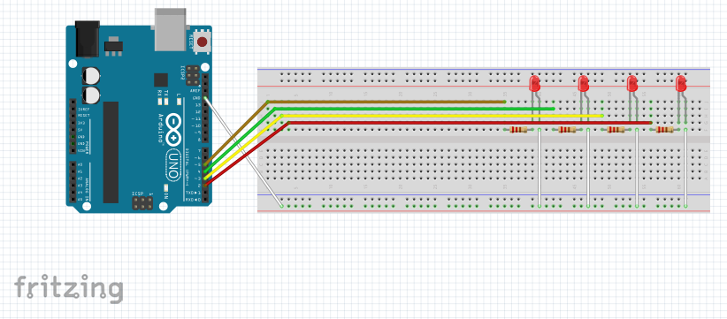
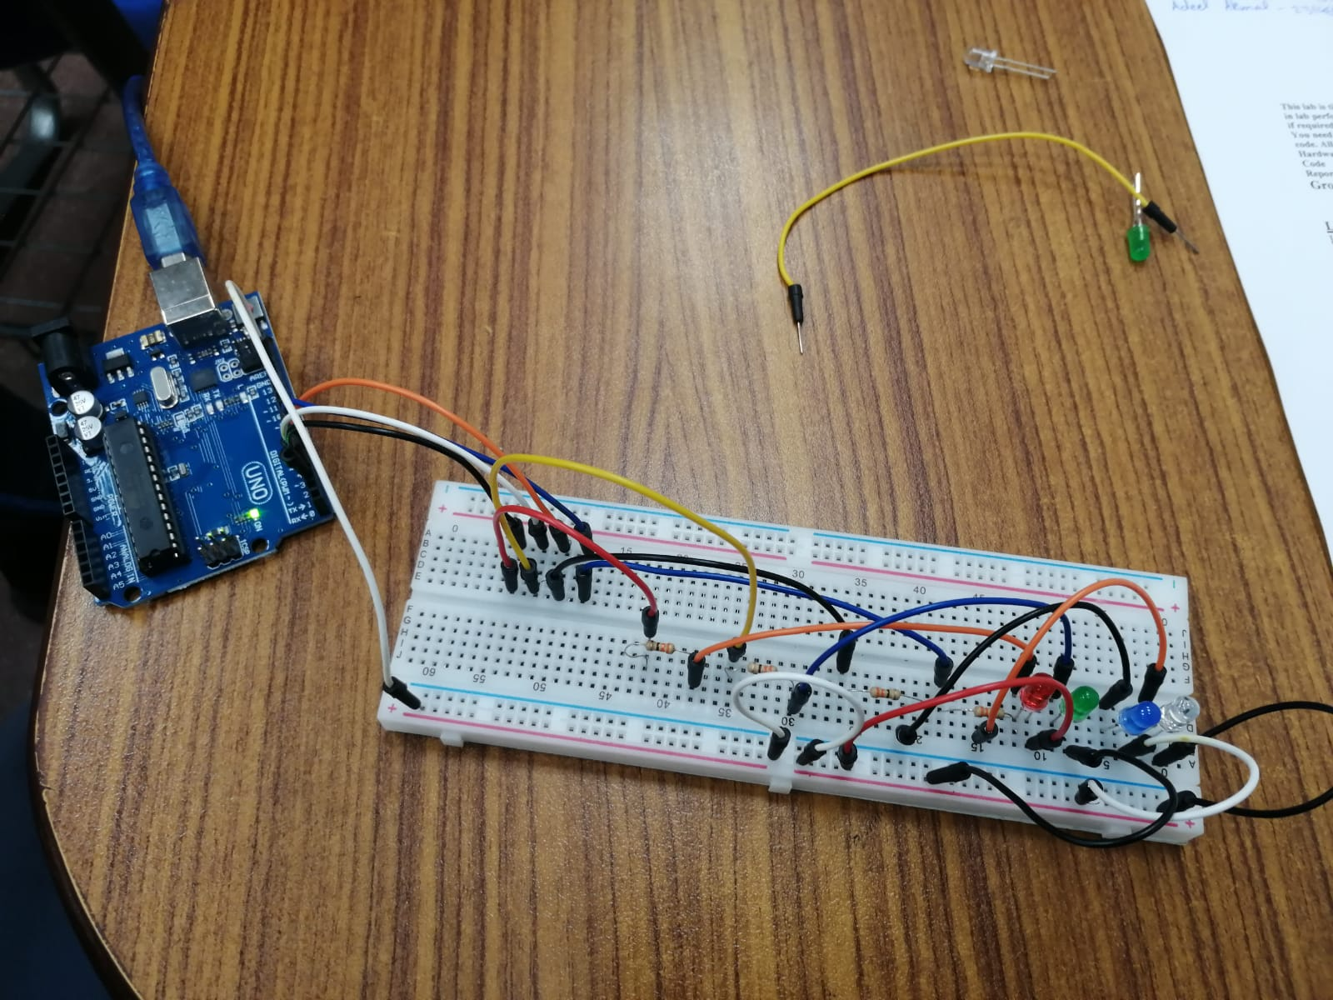

OUTPUT:

